LINEAR REGRESSION MODEL FOR ANALYZING ROAD ACCIDENT

This model can be beneficial for traffic accident analyzing and prevention in undeveloped countries by some of the following ways

1.Identifying risk factors that can cause accident by analyzing historical data ie. Weather, road condition, and time of the day.

2.If the model is trained and validated can be used to as an early warning system by continuously monitoring the relevant variables and providing real time warnings.

3.The model can assist in infrastructure planning as it can help in identifying accident prone areas and give a decision about design and traffic management and construction of safety features

4.This model can predict the severity of accidents helping emergency services to prepare for various scenarios and allocate resources accordingly.

5.The model can be used to evaluate the effectiveness of safety measures and policies after they are implemented.

MODEL CODE

import matplotlib.pyplot as plt  
import numpy as np  
import pandas as pd  
from sklearn.linear_model import LinearRegression  
  
data=pd.read_excel(r"C:\Users\Nyatundo Eric\Desktop\Accident_dataset.xlsx")  
  
  
x = data['SPEED'].values.reshape(-1,1)#indpendent variable  
y = data['SEVERITY'].values.reshape(-1,1)#dependent variable  
  
reg=LinearRegression()  
reg.fit(x,y)  
  
print(reg.coef_[0][0])  
print(reg.intercept_[0])  
  
predictions=reg.predict(x)  
  
plt.figure(figsize=(16,10))  
plt.scatter(  
 data['SPEED'],  
 data['SEVERITY'],  
 c='black'  
)  
  
plt.plot(  
 data['SPEED'],  
 predictions,  
 c='blue'  
)  
  
plt.xlabel('SPEED')  
plt.ylabel('SEVERITY')  
plt.show()

SCREENSHOTS OF ANALYZED ACCIDENT SEVENITY AND SPEED

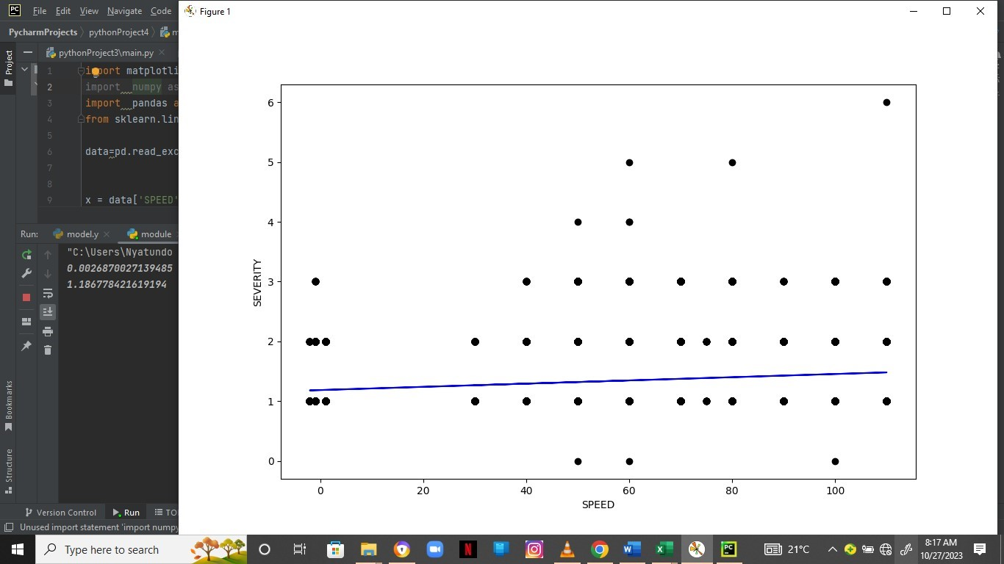

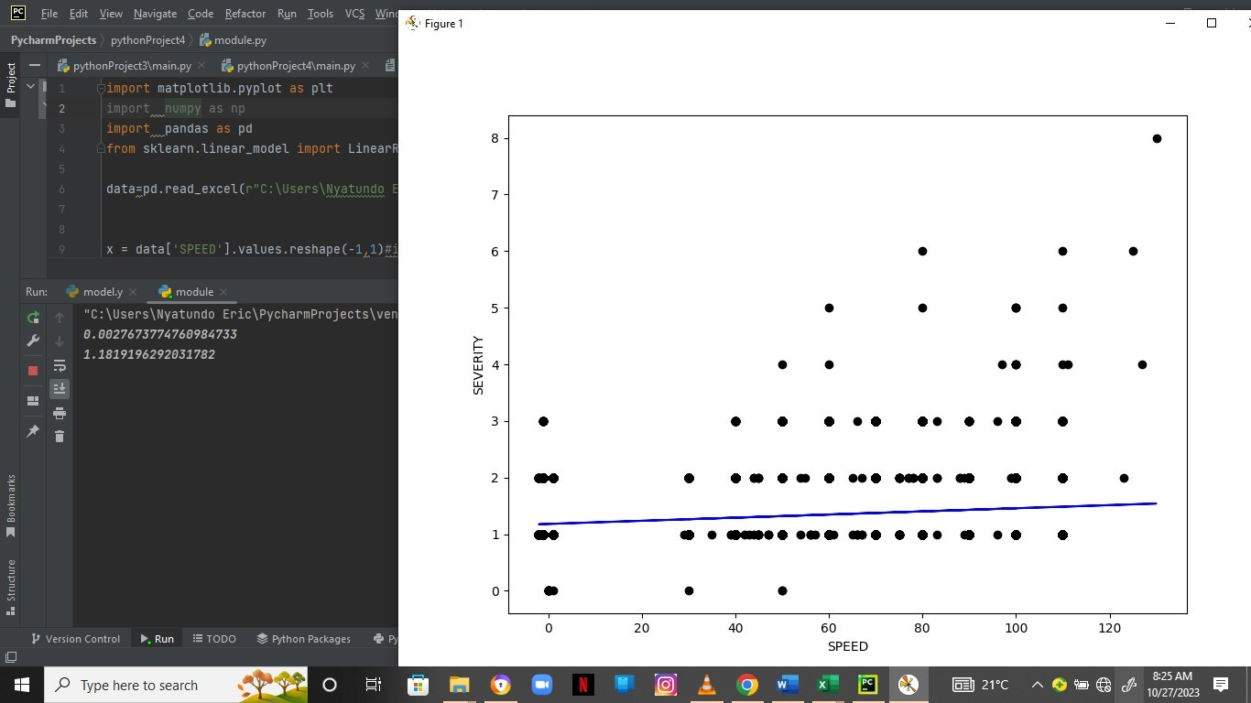

SPEED_ZONE AND SOVENITY

